***Business Model - The Empathy Map***

Design Thinking - Assignment

Udaya Bhaskar Reddy M

# Designed for: Designed by:

Customer Perspective:

# Date: Interation:

Wants a solution to the overcrowded train network

Wants a solution to the parking problem.

Efficient use of technology to solve problems

How to balance her work and school

Maximize time usage

Technology can solve problems

What does she

Traditional ways that don’t offer effective solutions.

Every day problems with Transportation

***THINK and FEEL?***

what really counts

major preoccupations worries & aspirations

You can find cool routes on the internet

What does she

***HEAR?***

You can find cool apps on the internet

what friends say

what boss says what influences say

Influenced by family and friends

What does she

***SEE?***

environment

Cannot find a parking app that solves her problem

friends

Cannot use overcrowded trains for transport

what the markets offers

What does she

***SAY and DO*** ?

attitude in public

appearance

Likes to search online

Uses Smart phone round the clock

behavior towards others

Likes to organize her daily routine in a timely manner.

Suggests efficient solutions

To feel in control of her day

Parking information is not real time/Overcrowded trains

Inefficient usage of time

**PAIN**

fears, frustrations, obstacles

**GAIN**

“wants”/needs, measures of success, obstacles

Work/School Balance

Effective time management

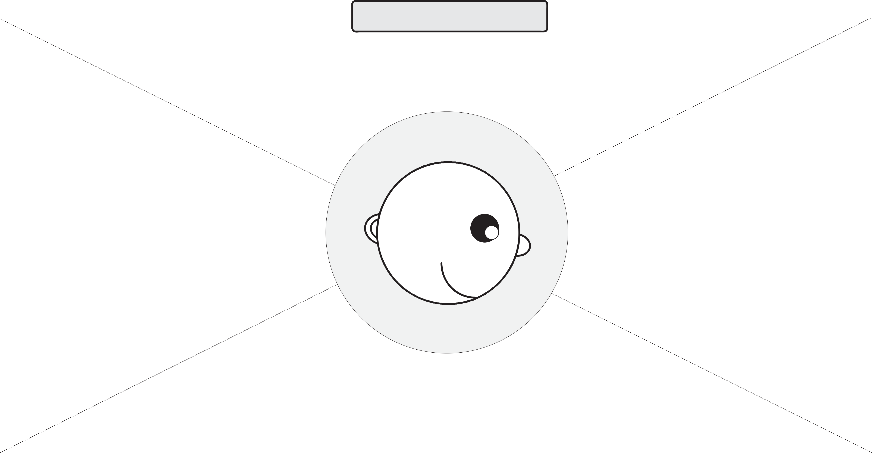

### Adapted from XPLANE. XPlane.com